Birding the pristine eastern Himalayas: Incredible Bhutan – trip report, November 2010
Our first trip to Bhutan was remarkably successful and we found all the main eastern Himalayan specials we were hoping for, while thoroughly savoring the spectacular scenery and strikingly beautiful architecture of this quant and peaceful land. This was certainly one of the best countries I have ever visited – on many counts – and you will see my excitement in the writing below.
Top 10 birds: Himalayan Monal, Satyr Tragopan, Beautiful Nuthatch, Ward’s Trogon, White-bellied Heron, Ibisbill, Black-necked Crane, Rufous-necked Hornbill, Rufous-bellied Eagle, Fire-tailed Myzornis, Wallcreeper, Black-eared Shrike-babbler and Yellow-rumped Honeyguide (OK, 13 – too tough to choose!)
Top 5 mammals: Leopard Cat, Black Giant Squirrel, Golden Langur, Yellow-throated Martin and Yak.
Top 5 sights: Tiger’s Nest Monastery precariously-positioned on a ledge high up on a cliff, Mount Everest and a string of other spectacular snow-capped Himalayan peaks, many of the impressive Dzongs (we visited the inside of one in Thimphu), beautiful houses and other buildings and the pristine forests covering most of the slopes.
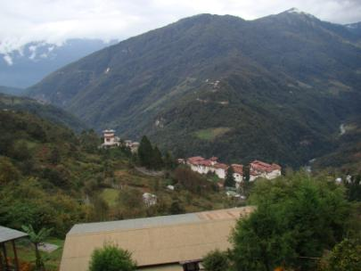
Day-by-day account:
Day 1, Nov 8: Duan and I met up in fascinating and bustling Kolkata, India, and took a flight to Bagdogra, seeing the fabulous snowcapped Himalayan peaks - including Everest - just before we landed. We then embarked on the four hour drive to Phuntsholing, a town straddling the India/Bhutan border. After crossing “Bhutan Gate” onto the Bhutanese side of this town, we were awestruck by the incredible contrast in atmosphere between the two countries. Bhutan is so quiet, peaceful and empty in comparison to India.
Day 2, Nov 9: the vast Indian plains abruptly meet the Himalayan foothills right at the border, and today we starting ascending into the beautiful forested hills of a dreamworld-like land. Well over half the surface area of Bhutan is still covered in pristine forest, and one gets the distinct impression that conservation is an important part of the psyche of Bhutanese people. The newspapers are full of conservation stories daily. As we made our first excited birding stops as we ascended the winding road, so we found our first of a fine suite of FULVETTAS, LAUGHINGTHRUSHES and other awesome Oriental bird families. Raptors were great today, with the likes of INDIAN BLACK EAGLE affording really close-up views, CRESTED GOSHAWK and MOUNTAIN HAWK-EAGLE. RED-BREASTED PARAKEET, SMALL NILTAVA (with shining blue hues) and BLUE-THROATED BARBET added spectacular color to the scene, as did the pretty BLUE WHISTLING THRUSH and nothing short of gorgeous WHITE-CAPPED WATER REDSTART – both of which were extremely common throughout the rest of the trip. SPANGLED DRONGO with its weirdly-shaped tail and GREY TREEPIE were less colorful but equally spectacular-looking birds we encountered. It was also nice catching up with more widespread things like GREY WAGTAIL in the fast-flowing mountain streams. After a wonderful day of birding, we eventually arrived in Paro, an amazing high-altitude town with an international airport which will be the starting point of our future Bhutan tour departures.
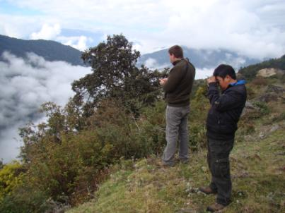
Day 3, Nov 10: After a comfortable night at our resort, we had an early start for the 4000 m altitude Chelela, the highest pass we would negotiate on this trip. Here, we found a male HIMALAYAN MONAL – one of the world’s most extravagantly-colored birds with its vivid rainbow hues - in the middle of the road ahead of us. Needless to say, we came to a rather abrupt halt and let this incredible bird continue its show. This is the stuff memories are made of and it is near-impossible to forget a birding experience like this! However, the day was still young and there was a great deal more on the cards for the morning! A flock of SNOW PIGEONS flew over, affording quite good views, while Duan photographed the snow-capped mountains in the distance (sadly he missed the pigeons!). Also near the top of the pass we heard some bird calls, followed them, and soon found ourselves in the midst of the most amazing mixed flock. Mixed flocks or bird parties were to become a real feature of this trip – each day producing numerous large and exciting flocks. One by one, we picked out the species – five TIT species including the fabulous YELLOW-CHEEKED, GREY-CRESTED and RUFOUS-VENTED, RUFOUS-BREASTED ACCENTOR, SCARLET FINCH, CRIMSON-BROWED FINCH, DARK-BREASTED ROSEFINCH, WHITE-BROWED ROSEFINCH, WHITE-WINGED GROSBEAK, DARK-THROATED THRUSH and many others. Four REDSTART species were around, including the striking WHITE-THROATED REDSTART. Back on the forested lower slopes, we located birds such as SPOTTED NUTCRACKER, TICKELL’S LEAF WARBLER (the first of a suite of Phylloscopus as well as more brightly-colored warblers in other genera), BLACK-BROWED (RUFOUS-FRONTED) TIT, striking WHITE-COLLARED BLACKBIRD and others. After a great day of birding, we spotlighted a LEOPARD CAT near Paro in the early evening before dinner.
Day 4, Nov 11: We left Paro early to get to our stakeout site for some MEGA-BIRDS soon after dawn. We were not disappointed, and obtained brilliant views of BLACK-TAILED CRAKE, the prized IBISBILL, the charismatic WALLCREEPER and some bonus birds like good, extremely LUCKY flight views of HILL PARTRIDGE, plus LITTLE RINGED PLOVER, RIVER LAPWING, RUDDY SHELDUCK, LITTLE BUNTING, chubby BROWN DIPPER and other goodies. Continuing on our journey culminating at our comfortable hotel in Bhutan’s amazing capital city (with stunning architecture), we found the rare YELLOW-RUMPED HONEYGUIDE at our stakeout, the striking LITTLE FORTAIL, LONG-LEGGED BUZZARD, KALIJ PHEASANT (close-up views), the dazzling GOLDEN-BREASTED FULVETTA in bamboo, GREEN SHRIKE-BABBLER, , CHESTNUT-CROWNED LAUGHINGTHRUSH and our second of all three TREECREEPER species, RUSTY-FLANKED.
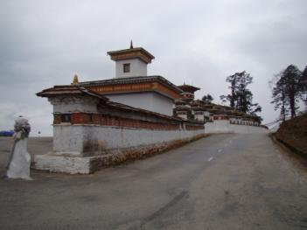
Day 5, Nov 12: birding in Paradise continues! This was a day in which we found a particularly high volume of quality birds, including the likes of GOLDEN-THROATED BARBET, GREAT BARBET, RUFOUS WOODPECKER, RUSTY-FRONTED BARWING, HOARY-THROATED BARWING, BLACK-FACED WARBLER, three BUSH-WARBLER species, the well-marked and sought-after BROAD-BILLED WARBLER (in its own genus!), CHESTNUT-CROWNED WARBLER (arguably the most attractive warbler we saw on the entire trip), RED-BILLED LEIOTHRIX, CHESTNUT-TAILED MINLA (our first of all three MINLA species), three YUHINA species (we eventually saw all seven YUHINA species), YELLOW-BROWED TIT, two of Asia’s most fabulous sunbirds, GOULD’S and GREEN-TAILED, the awesome GOLD-BILLED MAGPIE, RED-HEADED BULLFINCH, YELLOW-BREASTED GREENFINCH, BARRED CUCKOO-DOVE and many others. A bit of time and patience was needed to eventually obtain brilliant views of the gorgeous and pitta-like CHESTNUT-HEADED TESIA, a bird we actually managed to stumble across a lot of on future days, much to our delight (it’s a funny and brightly colored little thing). We eventually arrived in the Wangdi Valley in the late afternoon, poised very well for finding one of the world’s rarest birds.
Day 6, Nov 13: our main target today was WHITE-BELLIED HERON, a bird that was historically widespread through the foothills of the eastern Himalayas, but it has declined dramatically and now has a world population of perhaps only 250. Today, Bhutan must be the best country for this species, but it is probably the most frequently-dipped special of this country. Thanks to excellent work by our extremely competent local guide, including a good amount of inside knowledge, we located this species and we were amazed to find how weird it was for a heron. A plethora of other birds entertained us today as well, including the likes of CRESTED SERPENT-EAGLE, beautiful SLATY-BACKED FORKTAIL, the petite LITTLE FORKTAIL, CRESTED KINGFISHER, RUFOUS-GORGETED FLYCATCHER, ULTRAMARINE FLYCATCHER, close views of the bizarre WALLCREEPER, HIMALAYAN SWIFTLET and some other WAGTAILS in addition to the abundant but striking WHITE WAGTAIL - WHITE-BROWED and YELLOW. Another highlight today was seeing the famous dzong at Punakha, situated idyllically at the confluence of two tumultuous rivers.

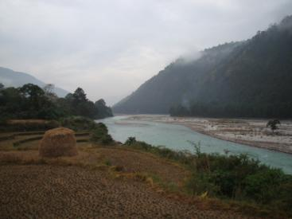
Day 7, Nov 14: today we headed eastwards, leaving the lovely Wangdi Valley behind us. Little did we know it that this was going to prove one of the most unforgettable days of our trip. A great thing about Bhutan is that a large amount of easy forest birding can be done from the road – the main paved roads in the country traverse and give access to miles and miles of pristine forest, all of which is absolutely remarkable for birding. A pair of the rare and sought-after WARD’S TROGON showed very close to the road, as did a FIRE-TAILED MYZORNIS. This emerald green bird with flashes of orange and red has to be seen to be believed and the close and prolonged views we obtained of this species, sometimes low down on the main trunk of a large tree, were wonderful. Some particularly beautiful doves observed today were EMERALD DOVE and WEDGE-TAILED GREEN PIGEON. The spectacular LESSER RACKET-TAILED DRONGO provided much entertainment. Really close views of RUFOUS-BELLIED WOODPECKER were thoroughly enjoyed, as were views of our first representatives of some fine Asian bird families – STREAK-BREASTED SCIMITAR-BABBLER, SHORT-BILLED MINIVET and GREAT PARROTBILL – AMAZING stuff! ASIAN and NEPAL HOUSE MARTINS were good to see before ending our day in Trongsa, poised for our exciting adventure the following day to the famed Zhemgang Road at bird-diverse low altitudes.

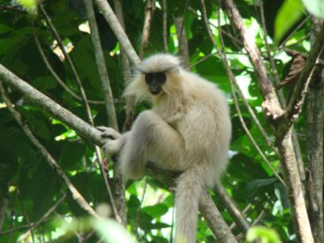
Day 8, Nov 15: as we descended to more tropical forests, so we continued to find unbelievably AWESOME birds as well as the localized and beautiful GOLDEN LANGUR (GOLDEN LEAF MONKEY). RUFOUS-BELLIED EAGLE, BLUE-BEARDED BEE-EATER, BAY WOODPECKER, the diminutive SPECKLED PICULET (amazing little woodpecker!), ORANGE-BELLIED LEAFBIRD, BLACK-CRESTED BULBUL (adding to our rapidly growing list of amazing Pycnonotus bulbuls – quite a thrill to see these spectacular-looking species after the paucity of representatives of this genus we are accustomed to in Africa), BLUE-WINGED MINLA, RED-TAILED MINLA, YELLOW-VENTED WARBLER, the beautiful WHITE-SPECTACLED WARBLER and GREEN MAGPIE were just some of the host of colorful birds we stumbled across today. Argument broke out as to whether SPOTTED FORKTAIL was in fact the most beautiful of this wonderful group of pied birds we had seen so far. Perhaps the most exciting mixed flock of the tour was about to be found, and included WHITE-CRESTED LAUGHINGTHRUSH, RUFOUS-NECKED LAUGHINGTHRUSH, WHITE-BELLIED YUHINA (undoubtedly our favorite of the seven YUHINAS of the trip), RUFOUS-BELLIED NILTAVA, flocks of the delightful BAR-WINGED FLYCATCHER-SHRIKE, gorgeous LONG-TAILED and SCARLET MINIVET, FIRE-BREASTED FLOWERPECKER, RUSTY-CHEEKED SCIMITAR-BABBLER and BLACK-EARED SHRIKE-BABBLER (one of the top trip birds).
Day 9, Nov 16: BEAUTIFUL NUTHATCH DAY! We found not one, but four of these extravagant nuthatches with powder-blue stripes on their wings, at our stakeout! Our day also included CHESTNUT-BELLIED NUTHATCH, WHITE-TAILED NUTHATCH, INDIAN BLACK EAGLE, ASIAN BARRED OWLET, an immense GREAT HORNBILL winging its way heavily over the canopy, LESSER YELLOWNAPE (a really spectacular woodpecker), ORANGE-BELLIED LEAFBIRD, NEPAL FULVETTA, BHUTAN LAUGHINGTHRUSH, RUFOUS-FACED WARBLER, WHITE-SPECTACLED WARBLER and the comical STREAKED SPIDERHUNTER. BLACK GIANT SQUIRREL was a wonderful mammal highlight today, quite a sight to see making its way slowly along a large tree limb.
Day 10, Nov 17: as we headed back to Trongsa we encountered numerous new birds for the trip. We were pleasantly surprised to find an immature LARGE HAWK CUCKOO, thanks to the eagle eyes of our great local guide. The rare RUFOUS-NECKED HORNBILL appeared, but we would have liked better views. GOLDEN BABBLER, YELLOW-CHEEKED TIT, GREATER YELLOWNAPE, CHESTNUT-BELLIED ROCK-THRUSH and GREY-CHEEKED WARBLER were other spectacular birds we were lucky enough to find today. SPECKLED WOOD PIGEON was seen briefly. We also had a close encounter with a striking-looking mammal, YELLOW-THROATED MARTIN, which suddenly appeared and had a good look at us while we were birding, then ran off again. Later in the trip, we saw several of these lovely animals, usually crossing the roads.
Day 11, Nov 18: we headed to Bumthang, where we easily found BLACK-BILLED MAGPIE, a bizarrely localized bird in Bhutan. We had great views of a perched BESRA, and saw our first HIMALAYAN GRIFFON. Other awesome birds today were YELLOW-BELLIED WARBLER, attractive WHISTLER’S WARBLER, HOARY-THROATED BARWING, FIRE-TAILED MYZORNIS (absolutely brilliant views for the second time during this trip) and RUFOUS-CAPPED BABBLER.
Day 12, Nov 19: We went to the beautiful Phobjikha Valley where we quickly found the spectacularly rare BLACK-NECKED CRANE (which migrates from the Tibetan Plateau). We plan to time our March tour to find this prized species before it heads back to Tibet, while also enjoying the spring bird activity and amazing floral displays of Rhododendrons and other flowers at this time of the year. Additional sightings in the peaceful valley (where we actually took a rare moment to relax) were HEN HARRIER, ORIENTAL SKYLARK and RED-BILLED CHOUGH. Earlier on, during the drive to get here, we saw DAURIAN REDSTART along with the ubiquitous HODGSON’S REDSTART, RED-BILLED LEIOTHRIX again, BLACK-THROATED TIT and EURASIAN SPARROWHAWK.
Day 13, Nov 20: in our March tour, we plan to head eastwards to bird the famed Lingmethang Road. However, during the current scouting trip, other factors necessitated now beginning to head west again, thus backtracking and eventually flying out of Bagdogra again. On the main tour, we may offer a pre-trip to look for RED PANDA, and we may do a post-trip looking for ONE-HORNED RHINOCEROUS and a host of lowland plains species just within India.
Despite beginning to head back west today, this nevertheless turned out to be one of the best days of the trip, affording close but brief views of the fabled and unbelievably spectacular SATYR TRAGOPAN, as well as other amazing birds such as the large and gaudy SPOTTED LAUGHINGTHRUSH and the very striking GREY-WINGED BLACKBIRD, in addition to ABBERRANT BUSH-WARBLER, GREY-CHINNED MINIVET, DARK-RUMPED ROSEFINCH and GREY-HEADED BULLFINCH. We arrived back in Thimphu and spent the afternoon doing a great cultural tour of the dzong there, with our knowledgeable Bhutanese guide (who was a jack of all trades and also knew the birding sites).
Day 14, Nov 21: we drove back to Phuntsholing, where we relaxed and took some time at the hotel to research our future trips to Bhutan.
Day 15, Nov 22: back in bustling and exciting India and en route to Bagdogra airport, we stopped to do some birding in the forest on the plains – quite different from the Bhutanese birding we had been doing over the last two weeks. We found some exciting bird parties which included such spectacular jewels as the gorgeous VELVET-FRONTED NUTHATCH, and CHESTNUT-BELLIED NUTHATCH, GREATER NECKLACED LAUGHINGTHRUSH, PUFF-THROATED BABBLER and many others. We also sampled the relatively high bird diversity of more open areas on the hot plains, compared to the lower diversity but high endemism of the higher altitudes of the eastern Himalayas, finding birds like RED-WATTLED LAPWING, BLACK IBIS, INDIAN ROLLER, SPOTTED DOVE, WHITE-THROATED KINGFISHER, LITTLE GREEN BEE-EATER, GRAY-CAPPED PYGMY-WOODPECKER, BLUE ROCK-THRUSH, ASHY WOODSWALLOW, CHESTNUT-TAILED STARLING and BLUE-FRONTED ROBIN. We eventually flew back to Kolkata and then immediately departed for SUNDERBANS NATIONAL PARK in the Ganges Delta area for a quick (24 hour) sampler trip there. On our approach to our lodge, we saw FLYING FOX, which is like a small flying dog or from a distance perhaps like a large eagle-owl.
Day 17, Nov 23: we awoke after a pleasant sleep in our expansive, comfortable rooms to see a sleepy-looking SPOTTED OWLET retire to its roost site under the eaves of one of the cabins for the day. We were then treated to a 5-star boat cruise on the river (including breakfast and lunch on the boat) – seeing a plethora of stunning KINGFISHERS including COLLARED, WHITE-THROATED, BROWN-WINGED and BLACK-CAPPED (some of the most gorgeous kingfishers I have ever seen). LITTLE GREEN BEE-EATERS also provided wonderful flashes of color. A BRAHMINY KITE gave a long flight view. Several LESSER ADJUTANTS were observed. A stop at an observation tower (from where we hoped, in vain, to see a BENGAL TIGER), was productive for LARGE CUCKOOSHRIKE, a calling GREATER COUCAL, GREENISH WARBLER and striking PURPLE-RUMPED SUNBIRD among others. Eventually we arrived at our landing from where we were to head back to Kolkata and home, but not without first seeing a spectacular woodpecker, the foot-long and colorful BLACK-RUMPED FLAMEBACK.
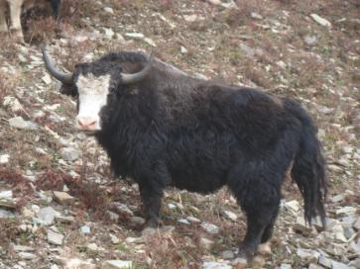
You, too, can bird the pristinely forested eastern Himalayas. Join us for 20 days in March 2011 for our next Bhutan trip:
Day 1: flight arrives in the highland city of Paro
Day 2: Chelela for high altitude species, second night in Paro
Day 3: Thimphu, the capital of Bhutan, for amazing birding and architecture
Day 4: bird to Wangdi Valley
Day 5: we bird the Wangdi/Phunakha area for a full day for White-bellied Heron and a host of forest birds.
Day 6: Phobjikha for Black-necked Crane and many other great birds
Day 7: Trongsa
Days 8-10: lowlands of Zhemgang
Day 11: Trongsa
Day 12: Jakar
Day 13: Sengor
Days 14-16: bird the famed Lingmethang Road
Day 17: Trashigang
Day 18: Narphung
Day 19: Samdrup Jonkhar
Day 20: into India for departure from Guwahati airport OR optional north-east India EXTENSION.

